Studio Shoot –Radio head

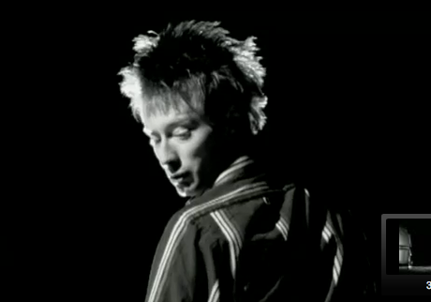
CU
Low angle
Backlighting
turns to look at camera
slo mo

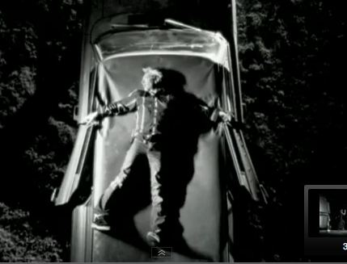
Wide shot
overhead
slomo

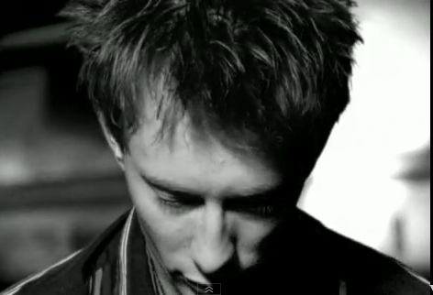
CU
Lighting from above moves from one side to other
slomo

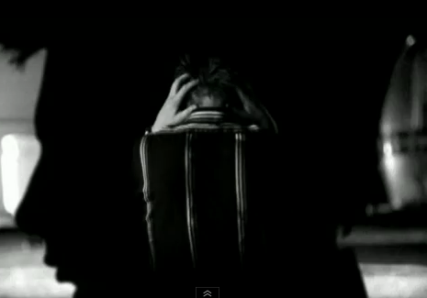
Layer 1 CU silhouette
Layer 2 side lighting

slomo

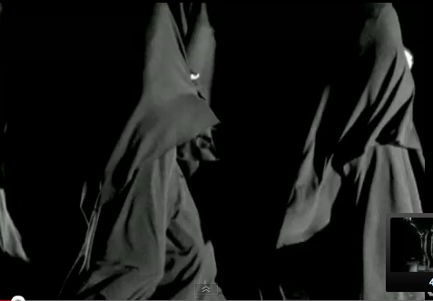
3 layers clothed figure swirling

slomo

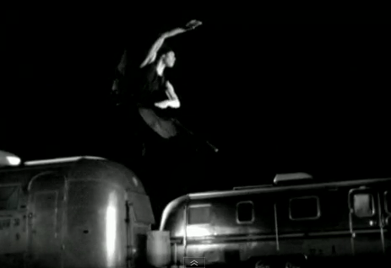
Figure jumping

slomo
Layer 2 ECU mouth
Layer 1 CU face
Camera moving
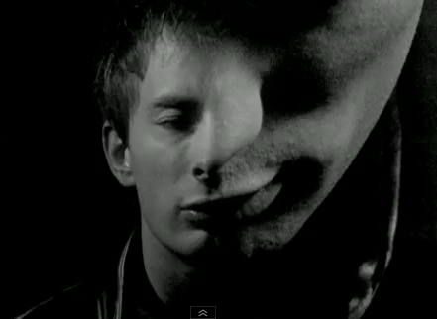

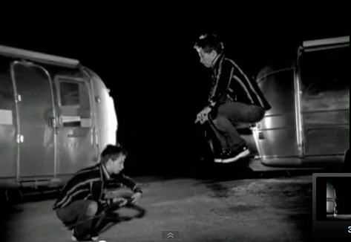
Layer 3 figure crouching
Layer 2 figure jumping
Layer 1 background
Layer 4
Layer 2 figure jumping
Layer 3
Layer 1 background
Slomo changing speeds
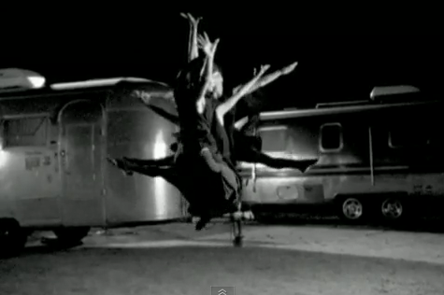

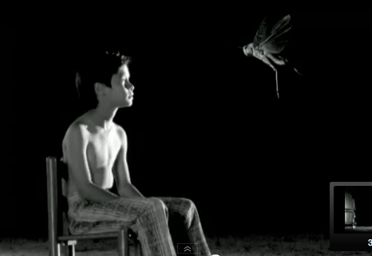
backlighting
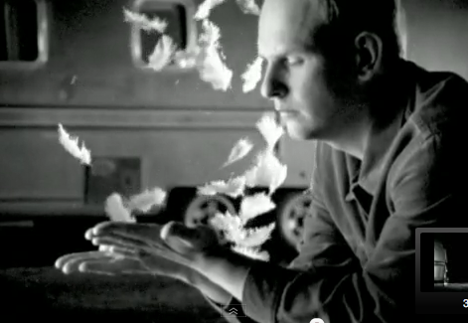

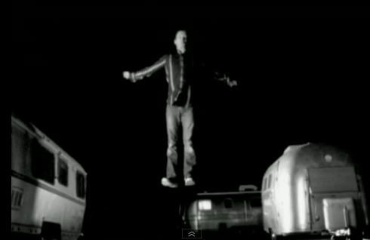
Layer 1 figure jumping
Layer 2 background

Slo mo

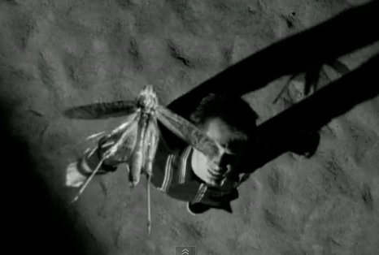
Overhead shot
Layer 1 figure
Layer 2 insect

Slo mo

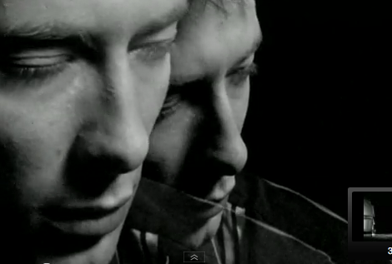

Portishead – Only You
Layer 1 background
Layer 2 face comes into light
-blue lighting
Slo mo


